Restaurant table reservation booking

Research paper
Present to Me. Archieliz asesor
Group 7
Presented by:
Denmark b Galindo
Hazel Anne A. Canoy
Reuben James M. DY
Manual daig Gil
Jun mark L. Salimbo

CHAPTER 1
THE PROBLEM
Introduction
The Restaurant Table Reservation System was developed to help restaurants manage customer bookings in a more organized and efficient way. Many establishments still rely on manual methods such as writing reservations in notebooks or taking verbal notes. These traditional methods can lead to errors like double booking, lost details, or difficulty tracking table availability. With this system, reservation tasks become easier because it automates recording, searching, and managing booking information.

This study presents a simple Python-based Restaurant Reservation System designed to assist in organizing bookings and managing customer information. By doing this it’s help improve basic reservation tasks, helps reduce human error, speed up the reservation process, and improve service quality. This project demonstrates how programming can provide practical solutions to real-world problems in the food service industry.

The system works by allowing users to view available tables, make reservations, search for customer bookings, and cancel them when needed. It automatically checks table capacity, assigns a suitable table, and stores important details such as the customer’s name, party size, and reservation time. With its simple and clear design, the system helps restaurants handle reservations more smoothly and avoid confusion.

Statement of the problem

General Problem
Restaurants using manual reservation systems face challenges in organizing bookings and ensuring that tables are assigned properly that lead to many mistake and error in the work.
Specific Problem
‎1. Difficulty in checking the availability of tables during busy hours.
‎2. Lack of a clear and organized list of customer reservations.
‎3. High chance of double booking or assigning the wrong table.
4. No fast method to search or filter reservation records.

Objectives of the Study
General Objectives
this study aims ‎To develop a functional Restaurant Table Reservation System that simplifies and improves the reservation process.
‎Specific Objectives:
‎

1.To create a system that displays available tables and their capacities.
2. To create a system that view all current reservations in a clear and organized format.
‎3. To provide a feature for adding reservations including customer name, party size, and time.
‎
4. To allow searching for reservations using the customer's name.
‎
‎5. To help reduce errors found in manual booking system.

Scope and Limitation
Scope

The system allows users to make reservations, view, search, and cancel reservations. It uses a text-based interface. It temporarily stores data in lists and dictionaries while the program is running. It Assigns tables based on available seating capacity. The system demonstrates basic programming Concepts such as loops, functions, and conditional statements.

Limitations

The program does not save data permanently; all information is lost once the program closes. The System does not check for overlapping reservation times. There is no graphical user interface (GUI) or Online access. The system cannot edit existing reservations except by canceling and adding a new one. Table assignment is based only on capacity, not reservation time or table availability schedule.

Flowchart
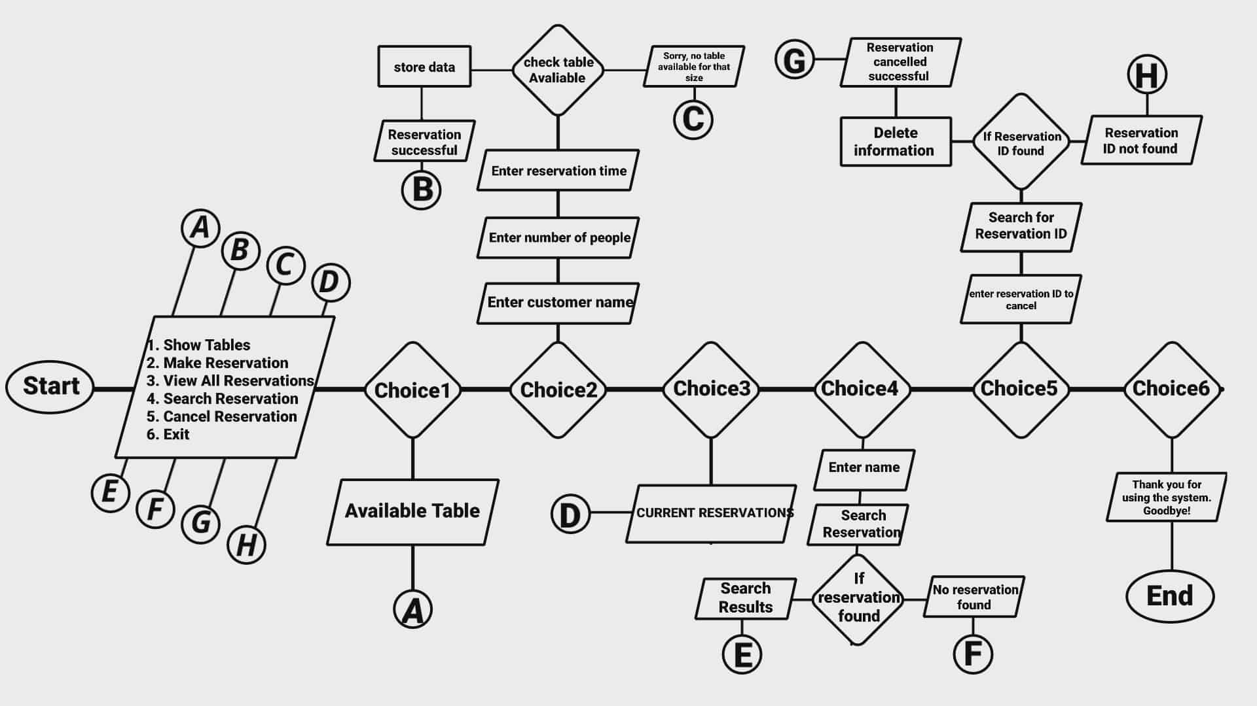

System requirements
- Programiz Online Compiler (or any Python IDE)
- Web browser (e.g., Google Chrome, Firefox, Edge)
- Operating System Requirements
- Windows 10 or later
- macOS
- Linux

